Experiment :-15

Problem Statement:-
Date and time manipulation is a common requirement in system administration, logging, and automation scripts. Linux provides powerful utilities to display and format date and time information. Additionally, measuring the execution time of a script helps evaluate performance and efficiency.
The problem is to write a shell script that changes the system date format as required and measures the time taken for execution of the script, thereby demonstrating date handling and performance measurement in Bash scripting.
Aim:- Shell script to change date format and measure execution time.
Procedure
A. Writing the Shell Script
1. Open the terminal.
2. Create a script file: nano date_time.sh
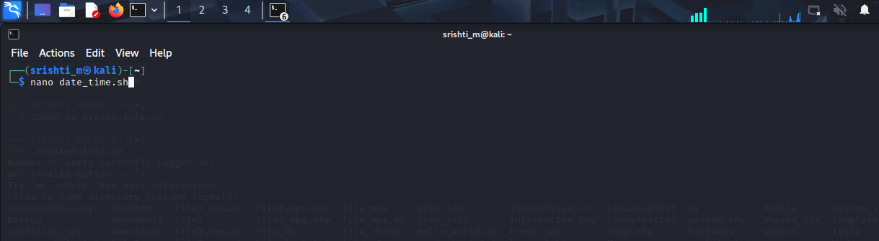
3. Enter the script:
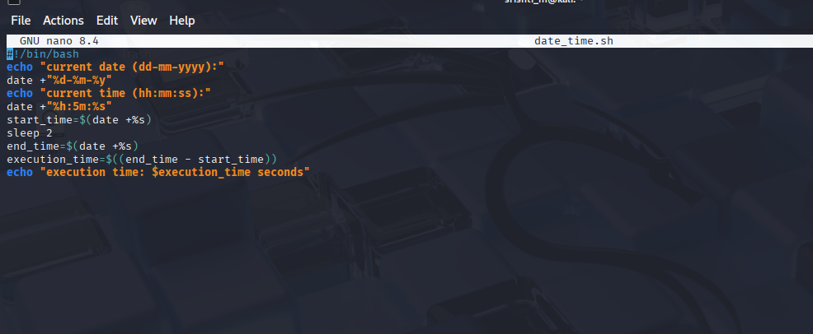

4. Save and exit the editor.
5. Make the script executable: chmod +x date_time.sh
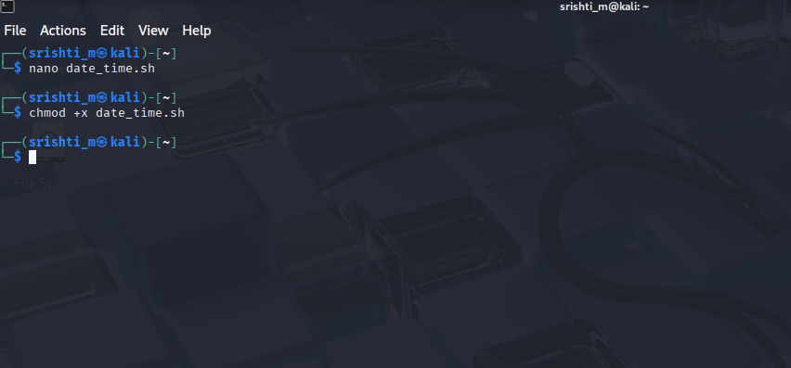
B. Executing the Script
6. Run the script with execution time measurement: time ./date_time.sh
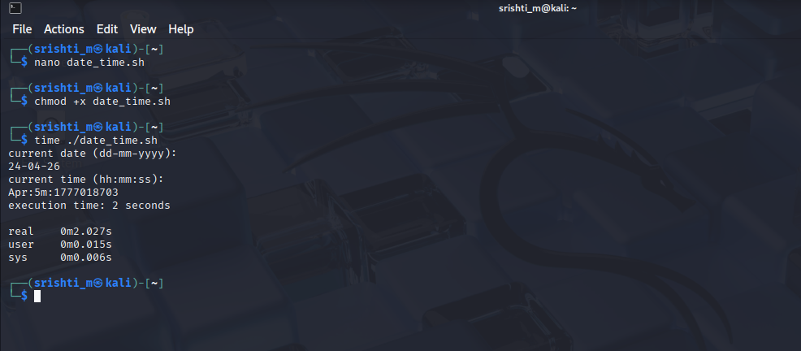
Expected Output:-
• Date and time displayed in customized format.
• Execution time calculated and displayed correctly.
• Script execution time measured using time command.
Result :-
A shell script was successfully written and executed to change the date format and measure the execution time, demonstrating date manipulation and performance evaluation in Linux.

